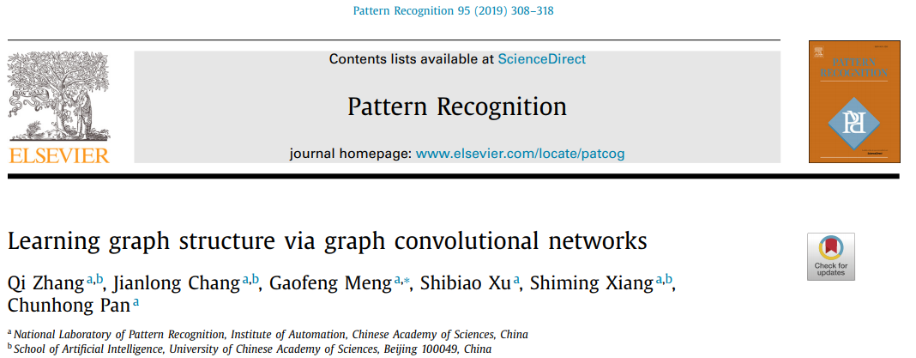

Graph convolutional neural networks have aroused more and more attentions on account of the ability to handle the graph-structured data defined on irregular or non-Euclidean domains.

Different from the data defined on regular grids, each node in the graph-structured data has different number of neighbors, and the interactions and correlations between nodes vary at different locations, resulting in complex graph structure. However, the existing graph convolutional neural networks generally pay little attention to exploiting the graph structure information. Moreover, most existing graph convolutional neural networks employ the weight sharing strategy which lies on the statistical assumption of stationarity. This assumption is not always verified on the graph-structured data. To address these issues, we propose a method that

GSCN, learns Graph Structure via graph Convolutional Networks , which introduces the

graph structure parameters measuring the correlation degrees of adjacent nodes.

The graph structure parameters are constantly modified the graph structure during the training phase and will help the filters of the proposed method to focus on the relevant nodes in each neighborhood.

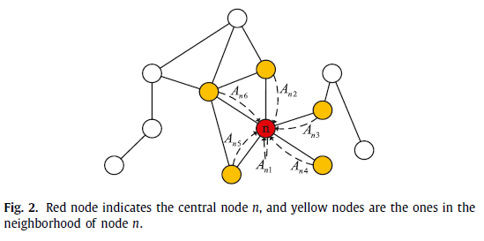 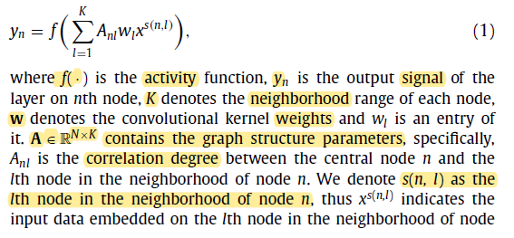

模型描绘中，图结构参数，矩阵A，中心点和邻点 的 correlation degree（类似邻接阵）

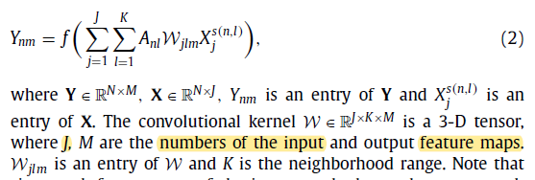 再套一层 feature map

多层图，不同层之间 A 可变，融合道路信息，高层 node abstracts the information related to a larger area including many roads.

达到效果 Two roads in the first layer may have low correlation degree or even are in- dependent, but in high layers, in the same place, two groups of roads may be closely related. Hence, this explains why the graph structures of different layers should be different from each other.

损失 函数 

Meanwhile by combining the graph structure parameters and kernel weights, our method, which

relaxes the restriction of weight sharing, is better to handle the graph-structured data of non-stationarity. In addition, the

non-linear activation function ReLU and the sparse constraint are employed on the graph structure parameters to promote GSCN to focus on the important links and filter out the insignificant links in each neighborhood.

Experiments on various tasks, including text categorization, molecular activity detection, traffic forecasting and skeleton-based action recognition, illustrate the validity of our method.